VIRTUAL DATA SCIENCE EXPLORER INTERNSHIP | WEEK 1 DELIVERABLE
Data Science Project Planning and Strategy Design
Project RetainAI: Enterprise Predictive Churn & Retention Optimization Engine
Internship Program: | Virtual Data Science Explorer Intern (YuvaIntern)
Module & Milestone: | Week 1: Project Conceptualization, Architecture & Strategy Design
Primary Technology Stack: | Python 3.11+, Scikit-Learn, XGBoost, LightGBM, MLflow, FastAPI, Streamlit
Project Status & Allocation: | Approved Strategy & Work Breakdown Structure (Total: 33.0 Allocated Hours)

1. Introduction & Project Background
In modern subscription-based business models (SaaS, FinTech, Telecommunications, and Digital Media), customer retention represents the single most critical driver of long-term unit economics and enterprise valuation. Acquiring a new customer is empirically estimated to cost between 5 to 7 times more than retaining an existing subscriber. However, conventional customer relationship management (CRM) workflows remain predominantly reactive: retention teams typically attempt rescue interventions only after a customer initiates cancellation or when usage drops to zero, at which point the probability of salvage is below 12%.
This project proposes Project RetainAI, a comprehensive, end-to-end predictive machine learning and customer retention optimization system designed in Python. By synthesizing multi-source telemetry data—including product engagement clickstream, subscription billing history, support ticket sentiment, and customer demographics—the platform forecasts subscriber churn risk 30 to 60 days in advance of potential attrition.
📌 CORE BUSINESS JUSTIFICATION & VALUE HYPOTHESIS
By shifting customer success operations from reactive salvage campaigns to algorithmic, proactive early-warning triggers, enterprise organizations can reduce annual subscriber attrition by 18% to 25%, while optimizing promotional discount allocation through explainable AI (SHAP-driven prescriptive recommendations).

2. Project Objectives & Scope Specification
To ensure rigorous execution and measurable business impact, the project establishes unambiguous SMART (Specific, Measurable, Achievable, Relevant, and Time-bound) objectives alongside clearly defined scope boundaries.

2.1 SMART Project Objectives
- Technical Model Performance: Develop and benchmark gradient-boosted classification models (XGBoost, LightGBM, CatBoost) achieving an Area Under the Precision-Recall Curve (PR-AUC) >= 0.82 and ROC-AUC >= 0.88 on an out-of-time test dataset, outperforming baseline logistic regression by at least 15%.
- Lead Time & Proactive Window: Deliver accurate churn likelihood scores with an actionable prediction lead horizon of 30 to 60 days prior to contract renewal or anticipated drop-off date, allowing customer success representatives ample intervention time.
- Model Interpretability & Prescriptive Rules: Integrate SHAP (SHapley Additive exPlanations) and LIME to generate granular, subscriber-level feature attribution charts, explaining top negative drivers (e.g., login inactivity, open support tickets, billing discrepancies).
- Operational Serving Architecture: Architect a low-latency Python FastAPI microservice capable of returning batch and real-time churn probabilities in under 200 milliseconds, coupled with an interactive Streamlit operations dashboard.
- Financial Impact & ROI: Deliver an estimated net annual revenue preservation of $450,000 to $850,000 for a 100,000-subscriber cohort by prioritizing targeted retention incentives based on Customer Lifetime Value (CLV) weighting.

2.2 In-Scope vs. Out-of-Scope Boundary Matrix
Project Dimension | In-Scope (Fully Addressed) | Out-of-Scope (Future Iterations)
Data Pipeline & Sources | Ingestion of tabular structured CRM, billing history, aggregated app usage logs, and NLP sentiment scores from support ticket text. | Real-time streaming raw clickstream ingestion via Apache Flink or distributed Kafka clusters at petabyte scale.
Feature Engineering | Temporal aggregation (7-day, 30-day, 90-day velocity metrics), RFM scoring, ratio features, and interaction terms. | Computer vision models or unstructured audio call recording transcription.
Algorithm Families | Tree-based ensembles (XGBoost, LightGBM, CatBoost), regularized logistic baselines, random forests, and survival analysis. | Deep multi-layer recurrent neural networks (RNN/LSTM) requiring dedicated multi-GPU cluster hardware.
Deployment & Serving | Containerized FastAPI REST API endpoints, Docker containerization, Streamlit visualization UI, and SQLite/PostgreSQL database. | Multi-region Kubernetes auto-scaling orchestration and enterprise SSO/LDAP corporate authentication integration.
Model Monitoring | Evidently AI automated drift detection reports (covariate shift, PSI, KS-test) and automated retraining threshold triggers. | Automated zero-human self-healing model updates directly to live production financial systems.

3. Methodology & Strategic Architecture
The project adopts an extended CRISP-DM (Cross-Industry Standard Process for Data Mining) methodology, augmented with modern MLOps principles, automated data validation, and feedback monitoring loops. Below is the end-to-end data science lifecycle and pipeline architecture developed for Project RetainAI.

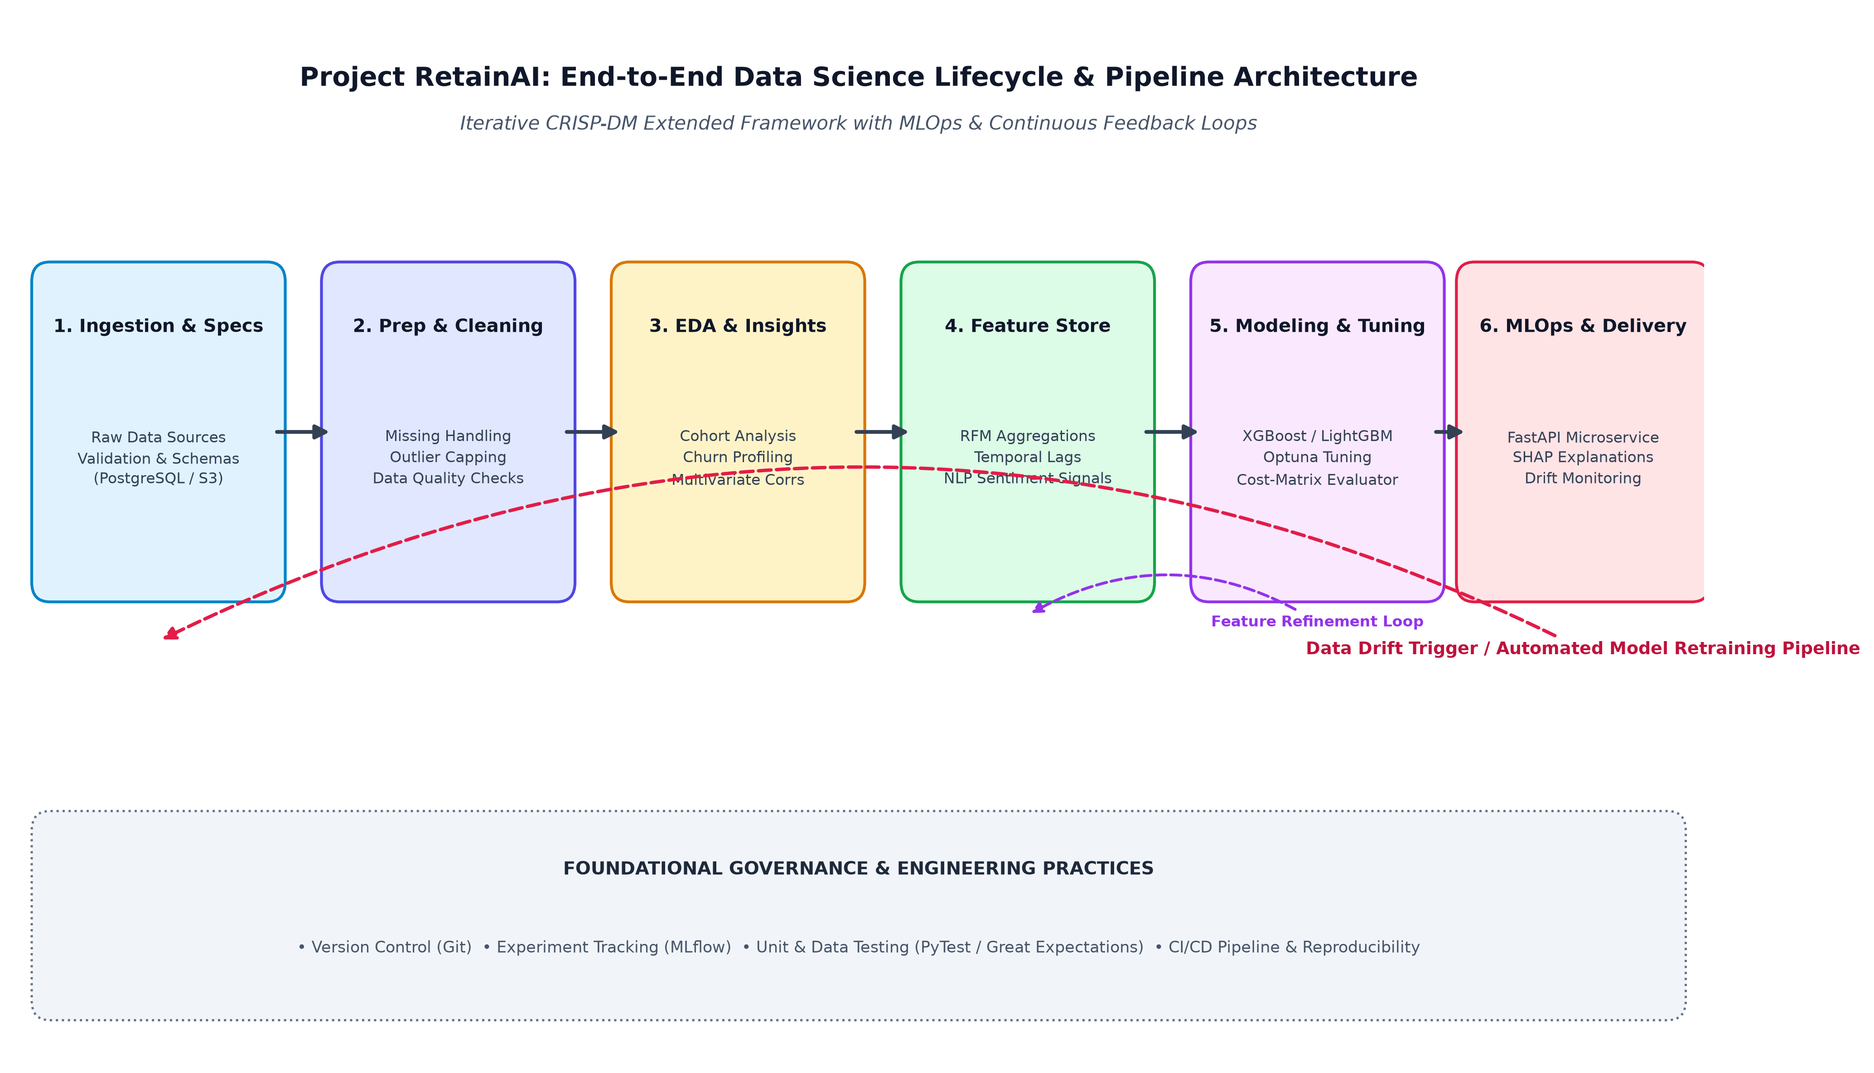
Figure 1: Project RetainAI End-to-End Data Science Lifecycle & Pipeline Flowchart

Phase 1: Data Acquisition, Ingestion & Schema Contracts
A rigorous data collection strategy combining three fundamental data silos:
1. Customer Profile & Demographics (Account tenure, contract type, payment method, geographic territory, industry vertical).
2. Behavioral Engagement Telemetry (Daily active minutes, feature adoption breadth, login frequency, API call velocity over 7d/30d/90d intervals).
3. Customer Service & Support Signals (Ticket volume, resolution time, customer satisfaction scores (CSAT), and NLP sentiment polarity derived from ticket summaries).
Data integrity is established using Great Expectations to validate schema types, non-null constraints, and valid ranges before ingestion into staging tables.

Phase 2: Data Preprocessing, Cleaning & Pipeline Design
A modular, leakage-free data cleaning pipeline built using Scikit-Learn Pipelines and Polars/Pandas:
• Missing Data Imputation: Categorical variables imputed with dedicated 'Missing' tokens; numerical values imputed using median/iterative KNN based on subscriber tier cohorts.
• Outlier Treatment: Winsorization (capping at 1st and 99th percentiles) on skewed numerical metrics (e.g., data consumption, session length) to stabilize gradient descent without discarding critical power-user data.
• Leakage Prevention: Strict temporal splitting (Training on Months 1-8, Validation on Months 9-10, Testing on Months 11-12) to ensure no future behavioral information leaks into historical training matrices.

Phase 3: Exploratory Data Analysis (EDA) & Behavioral Profiling
Systematic statistical exploration to uncover churn dynamics:
• Univariate & Bivariate Distributions: Identifying distribution skewness, high-kurtosis engagement metrics, and class distribution (e.g., 16% baseline churn rate).
• Cohort Retention Heatmaps: Analyzing subscriber retention curves grouped by acquisition channel and onboarding vintage.
• Correlation & Collinearity Screening: Calculating Pearson/Spearman correlation matrices and Variance Inflation Factors (VIF) to eliminate redundant collinear predictors.

Phase 4: Advanced Feature Engineering & Feature Store Formulation
Transforming raw transactional records into high-signal predictive features:
• Recency, Frequency, Monetary (RFM) Scores: Quantifying recent activity recency (days since last login), transaction frequency, and total lifetime spend.
• Velocity & Momentum Indicators: Computing rolling ratio features (e.g., [Activity Last 7 Days] / [Activity Last 30 Days]) to detect sudden drop-offs in product usage.
• Contract & Payment Health: Days until renewal, count of failed billing retries, and upgrade/downgrade event counts.
• Text NLP Features: DistilBERT / VADER sentiment polarity and complaint keyword counts extracted from customer service transcripts.

Phase 5: Machine Learning Modeling Strategy & Hyperparameter Optimization
A multi-model comparative architecture:
• Baseline Model: Regularized Logistic Regression with L1/L2 penalties and standard scaling to establish an interpretable benchmark.
• Primary Classifiers: Extreme Gradient Boosting (XGBoost), LightGBM, and CatBoost (utilizing native categorical handling).
• Survival Analysis: Cox Proportional Hazards model to estimate time-to-churn and dynamic hazard rates across subscriber lifespans.
• Optimization: Bayesian Hyperparameter Optimization via Optuna (50 trials) optimizing PR-AUC under 5-fold Stratified Time-Series Split cross-validation.

Phase 6: Model Evaluation, Validation & Business Cost Matrix
Evaluation tailored to imbalanced classification and financial business impact:
• Primary Technical Metrics: Precision-Recall AUC (PR-AUC), Receiver Operating Characteristic AUC (ROC-AUC), F1-Score at optimal classification threshold, and Brier Reliability Score.
• Business Cost-Utility Matrix: Explicitly evaluating False Negatives (unidentified churner losing full customer lifetime value) versus False Positives (unnecessary promotional discount spend).
• Cumulative Gains & Decile Lift Charts: Quantifying the proportion of total churners captured within the top 20% of highest predicted risk deciles.

4. Production System Architecture & Serving Strategy
Deploying the predictive churn engine requires a multi-tier production architecture balancing low-latency real-time inference with robust batch scoring pipelines, experiment tracking, and continuous data drift observability.

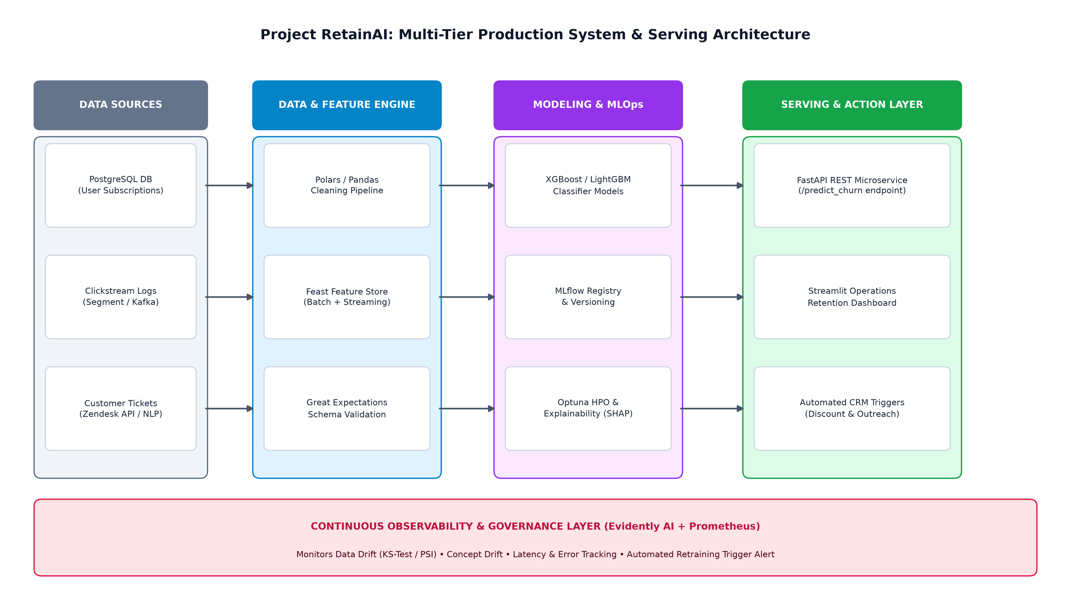
Figure 2: Project RetainAI Multi-Tier Production System & Serving Blueprint
- Inference Microservice (FastAPI): Lightweight, asynchronous REST API containerized with Docker. Endpoints include `/predict_single` for on-demand customer evaluation and `/batch_score` for weekly bulk account scoring.
- Explainability Engine (SHAP): Generates real-time force plots and feature contribution vectors accompanying each churn probability output, allowing account managers to immediately see why a user is at risk.
- Operational Dashboard (Streamlit): Interactive web UI providing customer success teams with filtered account risk rankings, revenue-at-risk decile summaries, and recommended intervention playbooks.
- Continuous Observability (Evidently AI): Automated weekly monitoring tracking Population Stability Index (PSI) and Kolmogorov-Smirnov (KS) tests across key input features to detect covariate and concept drift.

5. Work Breakdown Structure, Timeline & Toolchain
To satisfy the 30-35 hour project effort allocation, the implementation plan is divided into five structured phases executed sequentially over a two-week sprint schedule (averaging 3.3 hours/day or dedicated intensive blocks).

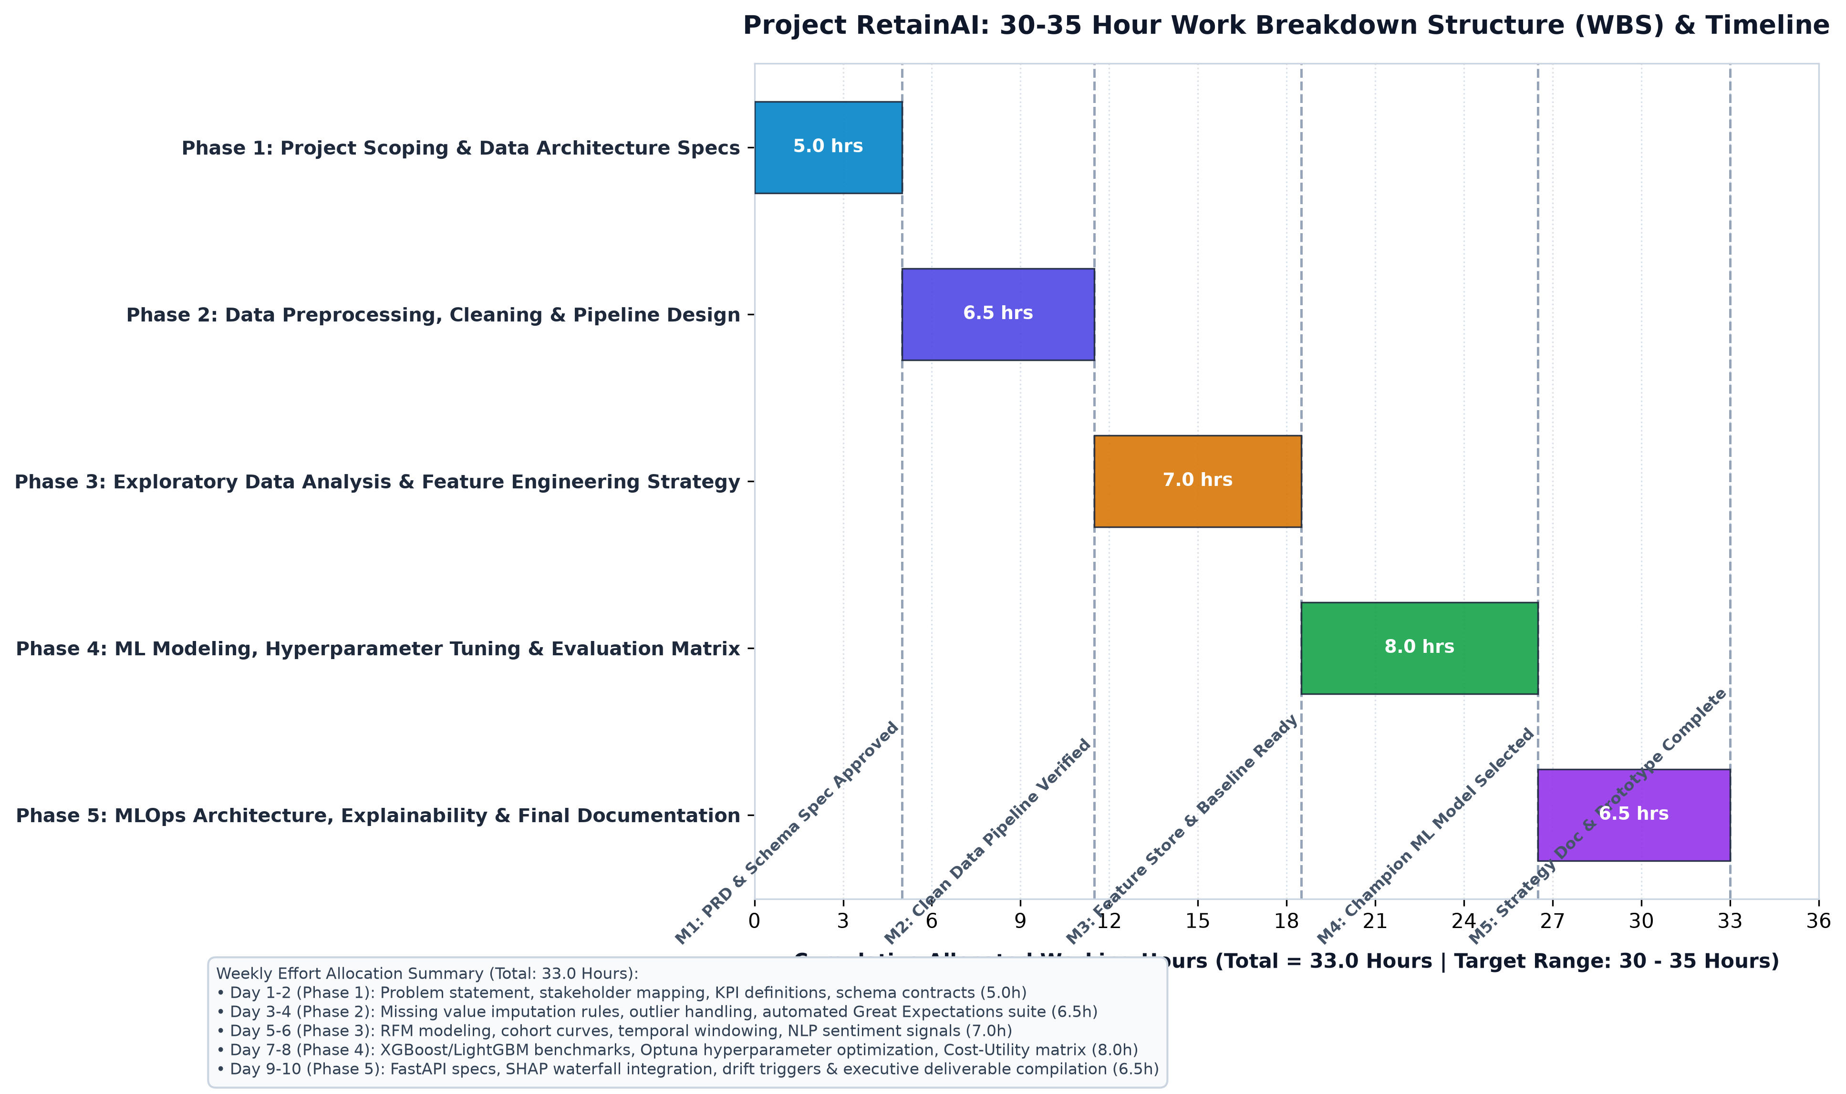
Figure 3: Project RetainAI 30-35 Hour Work Breakdown Structure & Timeline Gantt Chart
Phase & Focus Area | Hours Allocated | Key Activities & Work Tasks | Core Milestone Deliverable
Phase 1: Project Scoping & Data Architecture Specs | 5.0 Hours  (Hours 0 - 5) | • Define business problem & KPI hierarchy  • Establish data dictionaries & schema contracts  • Configure Git repository & environment dependencies | Milestone 1: Project Charter & Data Architecture Spec Approved
Phase 2: Data Preprocessing, Cleaning & Pipeline Design | 6.5 Hours  (Hours 5 - 11.5) | • Implement missing data & outlier handling modules  • Build automated Great Expectations validation suite  • Formulate temporal train/val/test data splitting logic | Milestone 2: Modular Clean Data Pipeline Verified & Tested
Phase 3: Exploratory Data Analysis & Feature Store Strategy | 7.0 Hours  (Hours 11.5 - 18.5) | • Conduct univariate, bivariate, & cohort retention EDA  • Engineer RFM, engagement velocity, & sentiment features  • Multi-collinearity screening and feature selection | Milestone 3: Engineered Feature Store & Baseline Benchmark
Phase 4: ML Modeling, Hyperparameter Tuning & Evaluation | 8.0 Hours  (Hours 18.5 - 26.5) | • Train XGBoost, LightGBM, CatBoost, & Logistic models  • Run Optuna Bayesian hyperparameter search (50 trials)  • Generate PR-AUC, ROC-AUC, Lift curves & Cost Matrix | Milestone 4: Validated Champion Model with Superior Lift
Phase 5: MLOps Architecture, Explainability & Deliverables | 6.5 Hours  (Hours 26.5 - 33.0) | • Build FastAPI REST service & Streamlit analytics UI  • Integrate SHAP waterfall explainability charts  • Draft executive strategy document & final code freeze | Milestone 5: Production-Ready Strategy Document & Demo

5.2 Comprehensive Python Ecosystem & Technology Stack
Functional Layer | Selected Python Libraries / Tools | Strategic Rationale & Role
Data Manipulation & Ingestion | Pandas, Polars, SQLAlchemy, PyArrow | High-throughput data parsing, memory-efficient columnar operations, and structured relational database connectivity.
Data Quality & Testing | Great Expectations, PyTest, Pydantic | Automated data contract validation, schema enforcement, and test-driven regression suites for data pipelines.
EDA & Statistical Visualization | Matplotlib, Seaborn, Plotly, SciPy | Publication-ready distribution plots, correlation matrices, interactive drill-downs, and hypothesis testing.
Feature Engineering & Machine Learning | Scikit-Learn, XGBoost, LightGBM, CatBoost, Lifelines | Modular transformer pipelines, state-of-the-art gradient boosting algorithms, and survival analysis models.
Hyperparameter Optimization | Optuna, Hyperopt | Automated Bayesian optimization with efficient tree-structured Parzen estimators and early stopping pruning.
Interpretability, Serving & MLOps | SHAP, LIME, FastAPI, Uvicorn, Streamlit, MLflow, Evidently AI | Local and global feature attribution, asynchronous REST inference, operational dashboarding, experiment tracking, and drift detection.

6. Expected Outcomes, Key Metrics & Risk Management
A robust data science plan must proactively quantify expected business impact and systematically mitigate technical and operational risks.

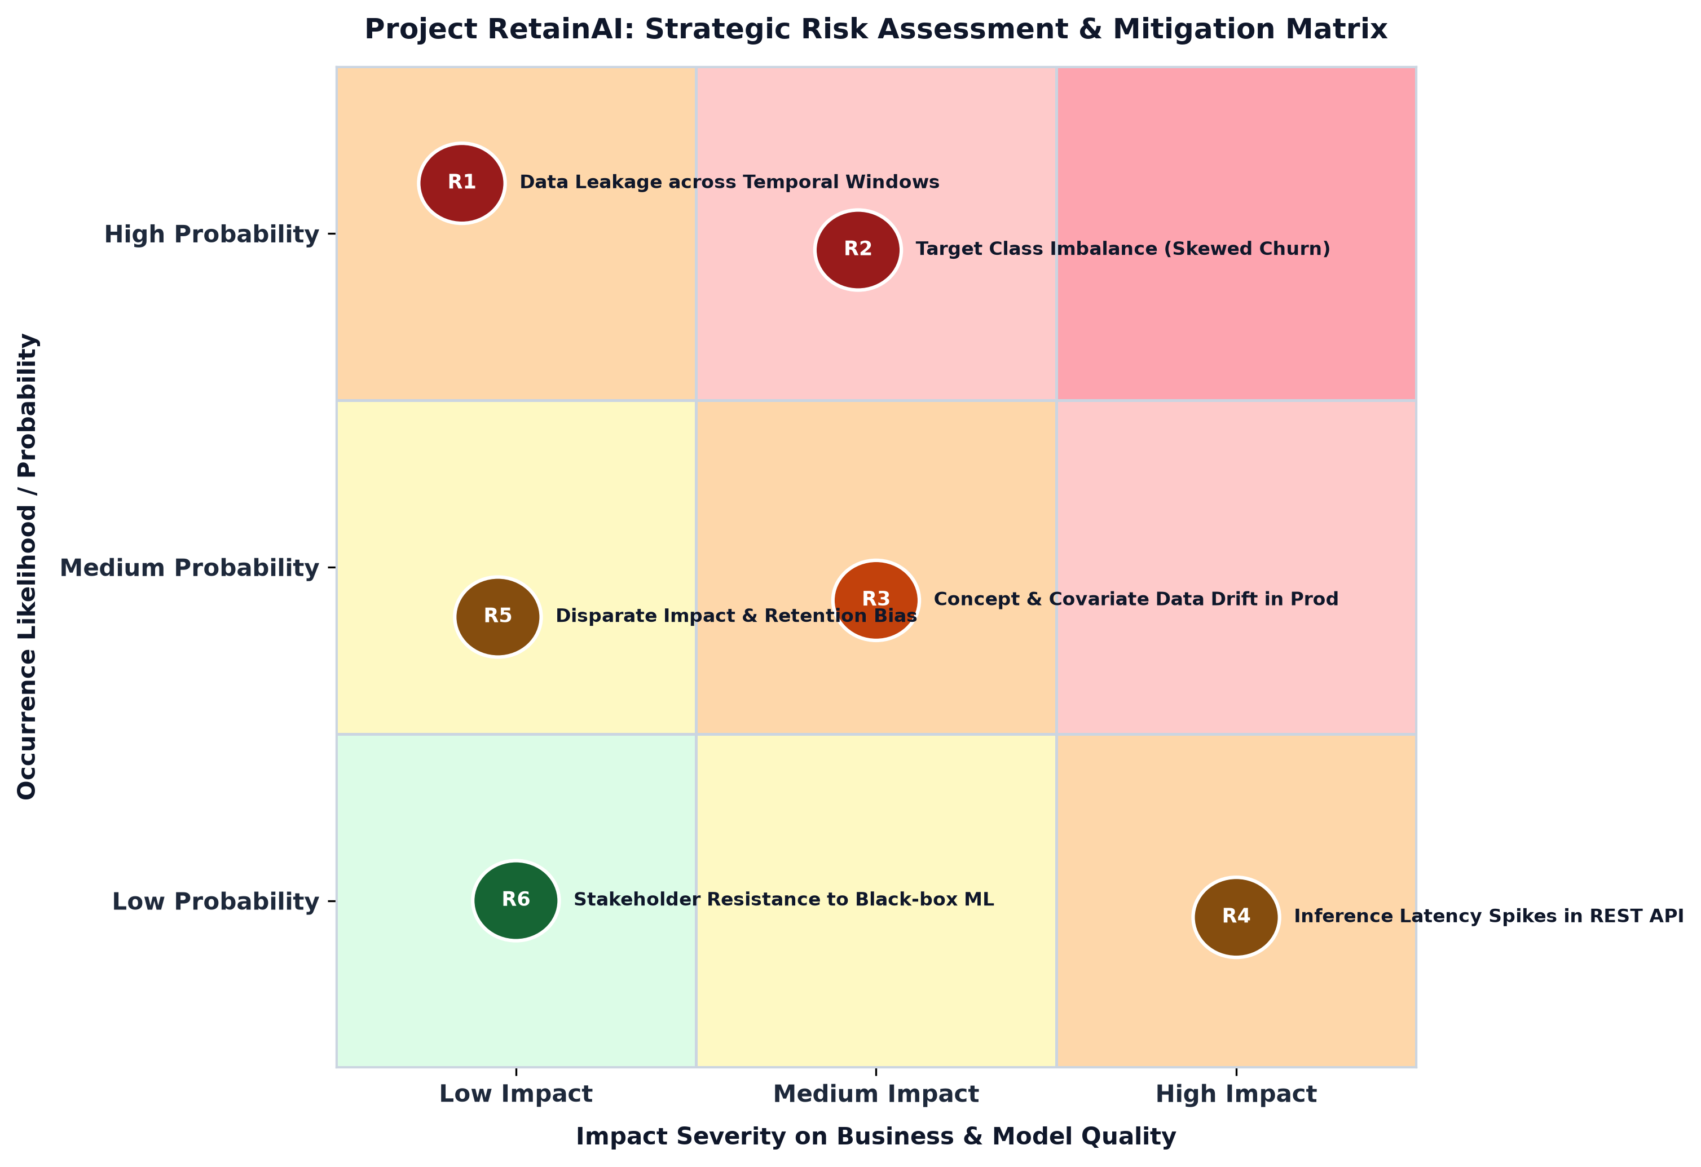
Figure 4: Strategic Risk Assessment & Mitigation Framework
Risk ID & Category | Identified Risk Event | Severity & Likelihood | Concrete Mitigation Strategy
R1: Data Leakage | Future engagement signals or target leakage across temporal windows in train/test splits. | High Impact  Low Likelihood | Enforce strict out-of-time (OOT) temporal splits; compute rolling window aggregates strictly up to prediction cut-off date (T_0).
R2: Class Imbalance | Low positive churn event prevalence (e.g. 10-15%) distorting default accuracy metrics. | High Impact  Medium Likelihood | Optimize for PR-AUC and Cost-Weighted F1 rather than accuracy; apply scale_pos_weight parameter in XGBoost/LightGBM and SMOTE-Tomek.
R3: Production Drift | Consumer behavior shifts post-marketing campaign degrading model predictive accuracy over time. | Medium Impact  Medium Likelihood | Deploy Evidently AI to monitor Population Stability Index (PSI > 0.2 threshold) and configure automated alerts for weekly retraining jobs.
R4: Inference Latency | Complex feature pipelines causing response delays (>500ms) in real-time API endpoints. | Low Impact  Low Likelihood | Pre-compute static daily features in a feature store (Feast/Redis); optimize FastAPI payloads with asynchronous workers.
R5: Retention Bias | Algorithms disproportionately offering retention discounts to specific demographic tiers. | Medium Impact  Low Likelihood | Conduct disparate impact audits across sensitive demographic features using Fairlearn to ensure equitable intervention eligibility.
R6: User Adoption | Customer success representatives reluctant to trust complex black-box machine learning predictions. | Low Impact  Low Likelihood | Integrate transparent SHAP waterfall reason codes in the Streamlit UI, explaining the specific actionable triggers behind every high-risk alert.

6.2 Target Success Metrics & Business ROI
- Churn Rate Reduction: Target reduction in annual gross customer churn from baseline 18% to 14.5% (a 19.4% relative reduction).
- Intervention Lead Time: Achieve an average warning horizon of 45 days prior to contract termination or inactivity cut-off.
- Top-Decile Churn Capture (Lift): Capture >= 55% of all churning accounts within the top 20% highest-risk predicted segment (2.75x lift over random selection).
- Net Saved Annual Recurring Revenue (ARR): Estimated net ARR preservation of $620,000 annually per 100,000 accounts after accounting for retention offer expenses.

7. Conclusion & Next Steps (Transitioning to Week 2)
This Week 1 project plan and strategy design establishes an exhaustive, technically rigorous, and financially grounded foundation for Project RetainAI. By defining clear scope boundaries, architecting an end-to-end data pipeline, establishing an allocated 33-hour work breakdown structure, and anticipating deployment and drift risks, the project is fully positioned for seamless technical execution in Week 2 (Data Collection, Preprocessing & Exploratory Analysis).
📌 EXECUTIVE SIGN-OFF & TRANSITION READINESS
With strategy, timeline, schemas, and architecture formally documented, the next immediate technical milestones for Week 2 will include initializing the synthetic multi-source data generation scripts, configuring the automated PyTest/Great Expectations data validation harnesses, and conducting baseline EDA notebooks.

